**Guided Media:**   
It is also referred to as Wired or Bounded transmission media. Signals being transmitted are directed and confined in a narrow pathway by using physical links.   
Features:

* High Speed
* Secure
* Used for comparatively shorter distances

There are 3 major types of Guided Media:

**(i) Twisted Pair Cable –**   
It consists of 2 separately insulated conductor wires wound about each other. Generally, several such pairs are bundled together in a protective sheath. They are the most widely used Transmission Media. Twisted Pair is of two types:

* **Unshielded Twisted Pair (UTP):**   
  UTP consists of two insulated copper wires twisted around one another. This type of cable has the ability to block interference and does not depend on a physical shield for this purpose. It is used for telephonic applications.

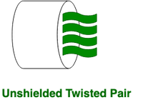

**Advantages:**

⇢ Least expensive

⇢ Easy to install

⇢ High-speed capacity

⇢ Susceptible to external interference

⇢ Lower capacity and performance in comparison to STP

⇢ Short distance transmission due to attenuation

* **Shielded Twisted Pair (STP):**   
  This type of cable consists of a special jacket (a copper braid covering or a foil shield) to block external interference. It is used in fast-data-rate Ethernet and in voice and data channels of telephone lines.

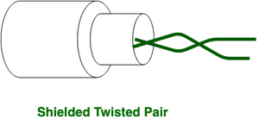

**Advantages:**

⇢ Better performance at a higher data rate in comparison to UTP

⇢ Eliminates crosstalk

⇢ Comparatively faster

⇢ Comparatively difficult to install and manufacture

⇢ More expensive

⇢ Bulky

**(ii) Coaxial Cable –**   
It has an outer plastic covering containing an insulation layer made of PVC or Teflon and 2 parallel conductors each having a separate insulated protection cover. The coaxial cable transmits information in two modes: Baseband mode(dedicated cable bandwidth) and Broadband mode(cable bandwidth is split into separate ranges). Cable TVs and analog television networks widely use Coaxial cables.

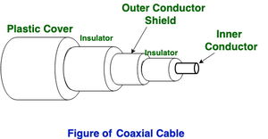

Advantages:

* High Bandwidth
* Better noise Immunity
* Easy to install and expand
* Inexpensive

Disadvantages:

* Single cable failure can disrupt the entire network

**(iii) Optical Fiber Cable –**   
It uses the concept of reflection of light through a core made up of glass or plastic. The core is surrounded by a less dense glass or plastic covering called the cladding. It is used for the transmission of large volumes of data.

The cable can be unidirectional or bidirectional. The WDM (Wavelength Division Multiplexer) supports two modes, namely unidirectional and bidirectional mode.

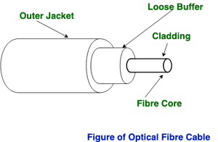

Advantages:

* Increased capacity and bandwidth
* Lightweight
* Less signal attenuation
* Immunity to electromagnetic interference
* Resistance to corrosive materials

Disadvantages:

* Difficult to install and maintain
* High cost
* Fragile